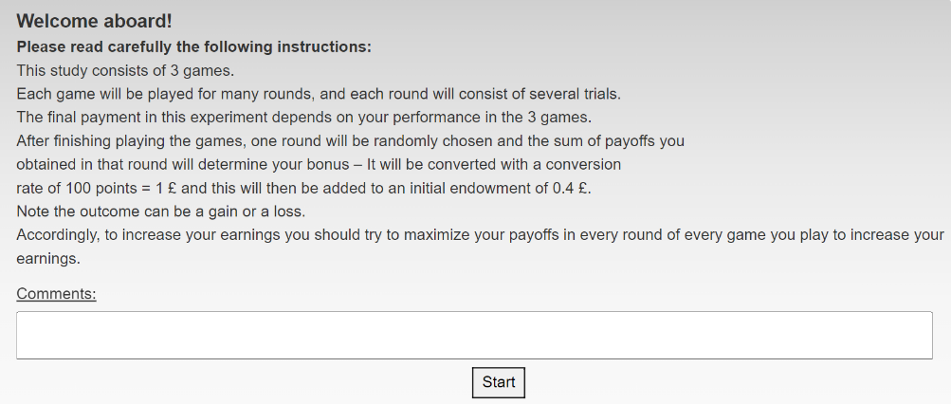

Keep this screen->

New version:

Old version:

In the next screen you will see two sets of unmarked keys. In each trial you will be asked to press a key and your payoff for that trial will be displayed on the key you selected. The current study includes 3 games, each consisting of several rounds. Each round, in all three games, includes 12 trials.

The first game includes 10 rounds.

The second game includes 20 rounds.

The third game includes 10 rounds.

You will be informed when each new trial, round and game begins.

Remember, your task is to obtain the highest payoffs in every round to increase your earnings.

To begin press – Start Game 1

Start Game 1

New version – relevant for each trial in each game!

Old version – relevant for each trial in each game!

You are on Trial # out of 12 trials in this round

Round # out of # rounds

Game # out of 3 games

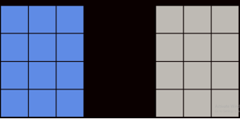

אחרי כל סבב:

Old version – relevant for each round in each game!

Old version – relevant for each round in each game!

You just finished round # in game #

In the next screen you will play this game again.

The payoff structure is the same, but all the keys have been reset and rearranged within each set of keys

continue

אחרי 20 סבבים (סיום משחק)

Final screen:

1. Thanks you for participating in this study! One round you played has been selected at random. You earned XXX points in that round, thus your bonus payment is CoinSign [InitialBonus +(XXX/ExchangeRatio)]. Please press the key below to get your Prolific completion code”

לשים לב: צד המטריצות נותר קבוע לאורך כל שלושת המשחקים (כלומר, מטריצה ימנית היא TRY היא תהיה כך לאורך כל שלושת המשחקים.

שינויים מהניסוי המקורי:

לשנות את העונש והפרסים בתנאים מ-1 ל-3

בניסוי המקורי רצו 2 משחקים- בייסיק ומשחק עם תנאי. במחקר הנוכחי צריך להוסיף משחק שלישי שהוא הבייסיק שוב.